CprE 381 – Computer Organization and

Assembly-Level Programming

Proj-B Report

Lab Partners _____________Muhamed Stilic_____________________

_____________Trevor Rowland_______________________

_____________Felipe V. Carvalho______________

Section / Lab Time ______Section 1: 8:00am/9:40am______________

Submit a typeset pdf version of this on Canvas by the due date. Refer to the highlighted language in the Proj-B instructions for the context of the following questions.

- [Part 0] How are instruction and data memory initialized in the simulation? How does MARS interface with ModelSim?

Instruction and data memory are initialized in the simulation by a .as or a .asm to test the design with. MARS interfaces with ModelSim by compiling the instructions to test from before, then it will check to see if the vhdl of the processor will compile and compare to the MARS compilation for any mismatches. Once that is done, there will be a victory and generate all of the values within that .asm file. It will even show the whole wave form once it’s done compiling.

- [Part 0] In the MIPS skeleton VHDL, how is a halting / termination condition detected? What MIPS assembly instruction does this correspond to?

The halting/termination in the skeleton code by reading the inputs of the amount of instructions and then the instructions themselves, If the instruction that is detected is HALT then it will stop, otherwise it will take in the next coming instruction. The mips assembly instruction that is related to this condition is jr. The reason it should be jr is because it can return and stop the simulation in mips by jumping to an area where it wont work.

- [Part 1 (a)] Modify the provided spreadsheet to include the list of M instructions to be supported in this phase alongside their binary Instruction OPcodes and Funct fields, if applicable. Create a separate column for each binary bit. Inside this spreadsheet, create a new column for the N control signals needed in your single-cycle processor implementation. The end result should be an M*N table where each row corresponds to the output of the control logic module for a given instruction. [You can attach the spreadsheet as a separate file, with a single spreadsheet for all Phase I and Phase II instructions.]

*FILE IS IN FOLDER AS*

control_signals_template.xlsx

- [Part 1 (b)] Implement the control logic module using whatever method and coding style you prefer. Create a testbench to test this module individually, and show that your output matches the expected control signals from part 1a). [Please include waveforms and explanations.]

WAVEFORMS:
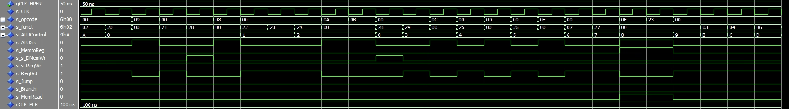
EXPLANATION:

This wave form shows how the control operates. When the control receives the opcode/funct from the IMem instructions. It will go through this control. This control will take apart the instructions and tell the what the signals should go out to the rest of the processor on what it should do. This wave form shows all of the phase 1 instructions. You can tell which ones are immediate due to the ALUsrc being 1. Only 1 mem to reg is lw. Sw is 1 to the s_s_DMemWr. The rest of the instructions basically have s_regDst 1 to make them go to where the bits need to in the ALU.

- [Part 2] In your writeup, provide your schematic for this part, describe what challenges (if any) you faced in implementing this module.

Schematic:
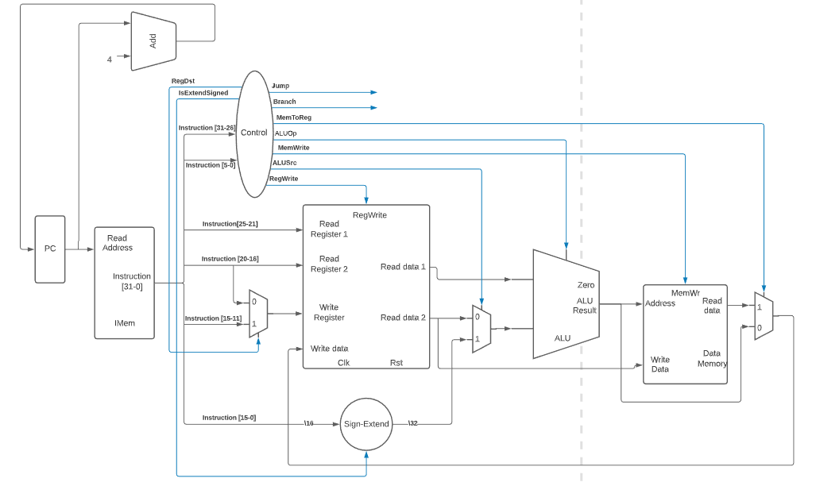

Challenges: The challenges were first to be overcoming the changes in our ALU/register to be combined into the processor given.

- [Part 4 (a)] Describe these possibilities as a function of the different control flow-related instructions.

These possibilities would be from ‘control-flow-related instruction’ as this ‘function’.

- [Part 4 (c)] Update your processor schematic for the instruction fetch logic and any other datapath modifications needed for control flow instructions. In your writeup, describe what additional control signals are needed.

The updated processor schematic. “PHASE 2”
FETCH LOGIC:

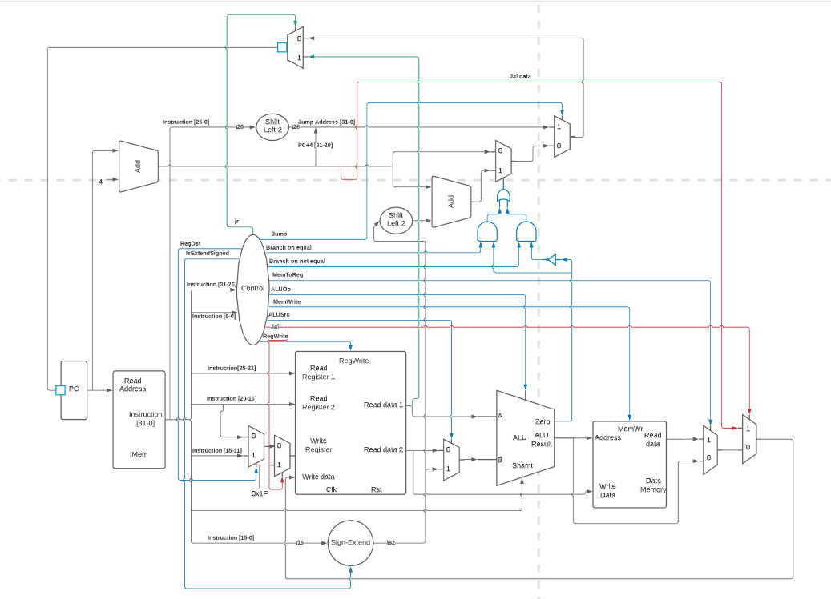

- [Part 4 (d)] Include ModelSim waveforms, and describe how the execution of the control flow possibilities corresponds to the waveforms in your writeup.

“PHASE 2”
WAVEFORMS:

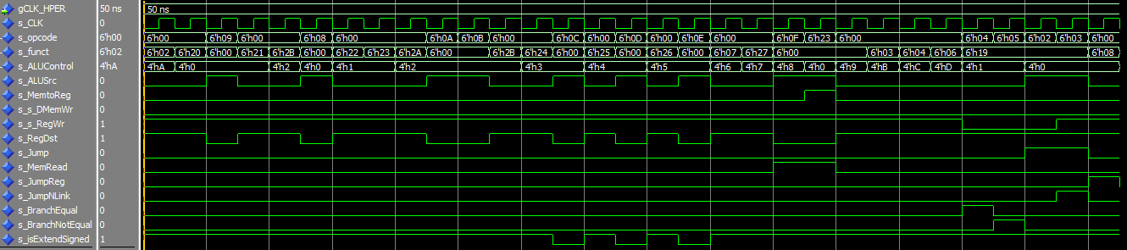

EXPLANATION:

This wave form shows NOTHING

- [Part 5 (a)] In your writeup, show the ModelSim output for the individual instruction tests, and provide a discussion of result correctness. It may be helpful to also annotate the waveforms directly.

WAVEFORMS Phase 1:

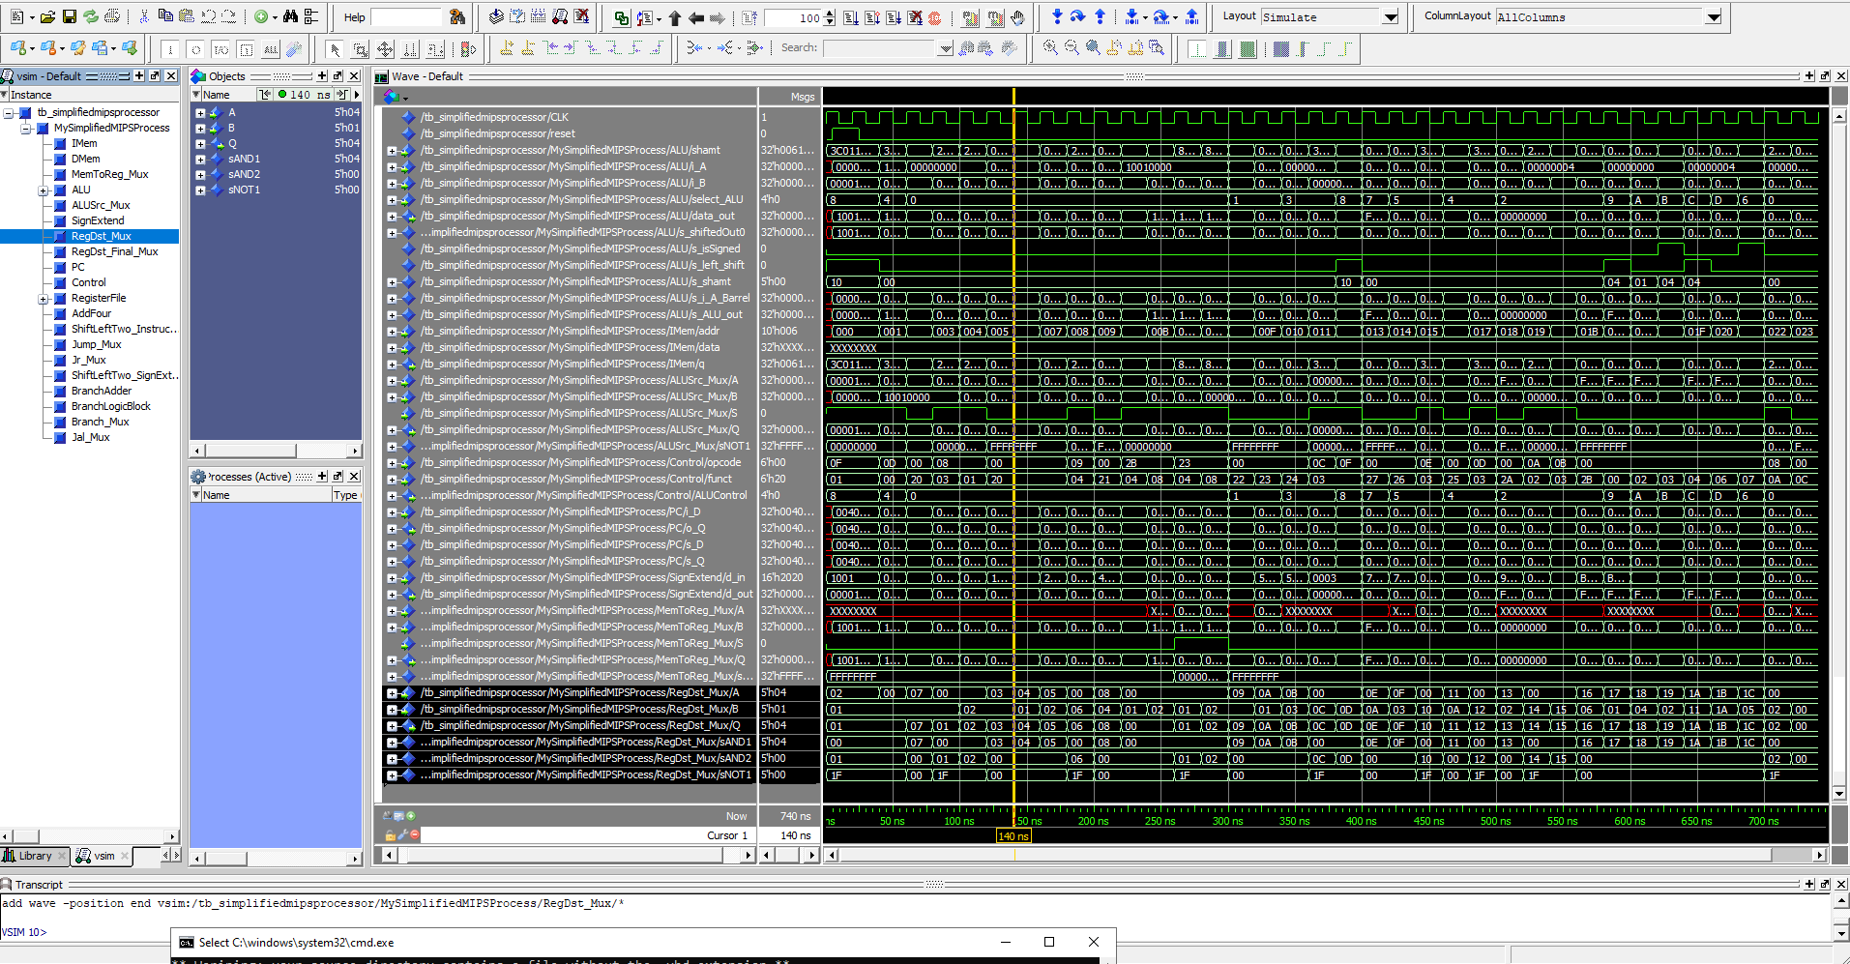

EXPLANATION:

This wave form shows the instructions add, addi, addiu, addu, and, andi, lui, lw, nor, xor, xori, or, ori, slt, slti, sltiu, sltu, sll, srl, sra, sllv, srlv, srav, sw, sub, and subu.

We clk, rst, alu, clm, pc

WAVEFORMS Phase 2:

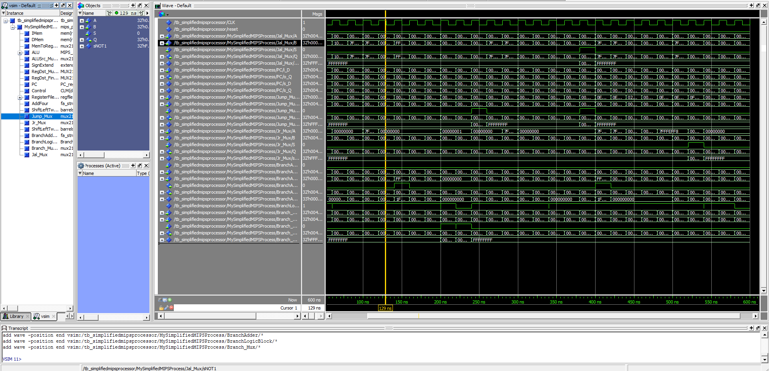

EXPLANATION:

This wave form shows the instructions beq, bne, j, jal, and jr.

- [Part 5 (b)] In your writeup, show the ModelSim output for the Bubblesort test, and provide a discussion of result correctness. It may be helpful to also annotate the waveforms directly.

WAVEFORMS:

EXPLANATION:

This wave form shows NOTHING

- [Part 5 (c) BONUS] In your writeup, show the ModelSim output for the Mergesort test, and provide a discussion of result correctness. It may be helpful to also annotate the waveforms directly.

We skipped Merge Sort. It’s a bonus.

- [Part 7] Report the maximum frequency your processor can run at and determine what your critical path is. Draw this critical path on top of your top-level schematic. In your writeup, briefly discuss your critical path results. What components would you focus on to improve the frequency?

Max Frequency: 17Ghz

Critical Path: LUI
Total Path: PC -> s_IMemAddr -> IMem -> RegisterFile -> ALUSrc -> ALU -> ALUBarrel -> ALUBarrelShifter -> ALUData_OUT -> DMem

We concluded that because of the way this data path is shown in the timming.txt. It looks like the critical path is the LUI instruction.

The components I would focus on to improve frequency would be any design that includes a clock and the ALU as it’s the one that takes the most amount of time.

The critical path design:

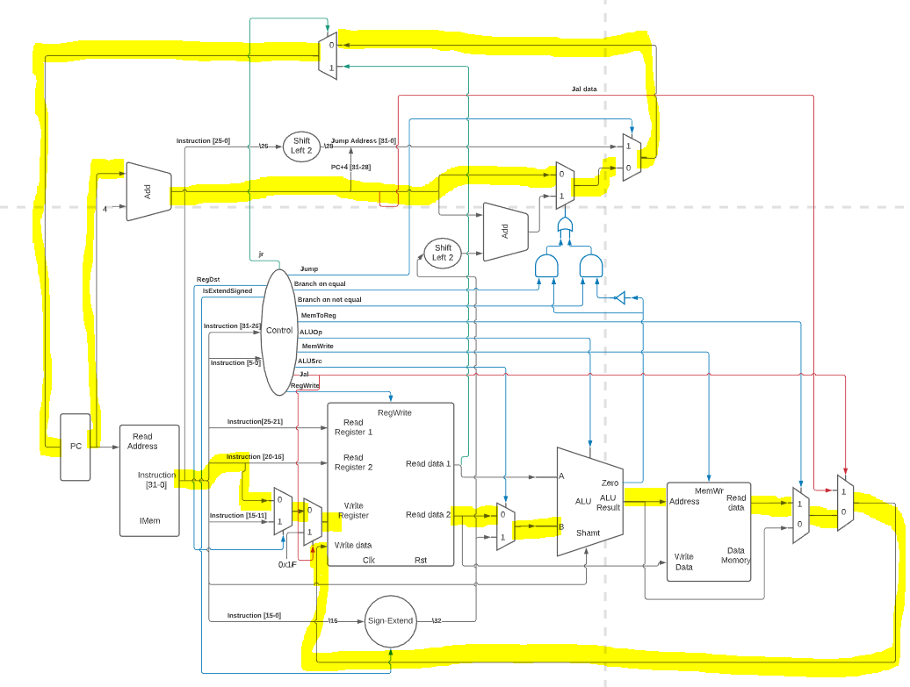

- [Feedback] You must complete this section for your lab to be graded. Please complete each column separately for each team member; I expect it to take roughly 10 minutes (do not take more than 20 minutes).

  - How many hours did you spend on this lab?

Task | During lab time |  |  | Outside of lab time
Team Initials | MS | TR | FC | MS | TR | FC
Reading lab
Pencil/paper design
VHDL design
Assembly coding
Simulation
Debugging
Report writing
Other:
Total

  - If you could change one thing about the lab experience, what would it be? Why?

Muhamed:

Trevor:

Felipe:

  - What was the most interesting part of the lab?

Muhamed:

Trevor:

Felipe:

